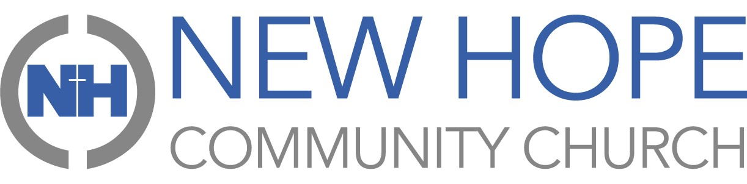
PRAYER CALENDAR Apr2025
Sun | mon | tue | wed | thu | fri | sat
 |  | 01 | 2 | 3 | 4 | 5
 |  | Lisa Zizzo (travel); Menke Family | Lyn Molzahn (health) | Worship Team | Beth Thompson (health) | Sunday Morning Ministries
6 | 7 | 8 | 9 | 10 | 11 | 12
Hope Kids/Fusion | Chris Ingler (health) | Amanda Fenwick (health) | Kenny & Lindy Enlow (health) | Hope Central | Lisa Zizzo (travel) | Sunday Morning  Ministries
13 | 14 | 15 | 16 | 17 | 18 | 19
Hope Kids/Fusion | Wendell Cron (health) | Stitches of Joy | Courtney Family | Holy Thursday | Transcendent Healthcare North; Good Friday | Sunday Morning Ministries
20 | 21 | 22 | 23 | 24 | 25 | 26
Hope Kids/Fusion; Easter Blessings | David Curl (health) | Youth First (Missions) | Studio Bee (Missions) | Business Team | Our community | Sunday Morning Ministries
27 | 28 | 29 | 30
Hope Kids/Fusion | Unsaved Family & Friends | Elder Team | Our church staff and volunteers
PERSONAL PRAYERS...
- Opportunities to be a loving, Spirit-filled witness for Christ.
- Courage to build spiritual friendships with people who are far from Jesus.
- Boldness to engage in spiritual conversations that lead to salvation.
- Effectiveness in making disciples who LOVE, GROW & SERVE.
RISING UP!

